

**A211 STIA1113 – PROGRAMMING 1 (GROUP C)**

**ASSIGNMENT 1**

**NAME: NOR AISYAH BINTI ABD HALIM**

**MATRIC NUMBER: 286982**

**TOPIC: BANK**

**SUBTOPIC: BUSINESS LOAN**

**LECTURER: PROF. MADYA DR. AZMAN B YASIN**

**SUBMISSION DATE: 19 DECEMBER 2021**

1. **Identify the problem**

Small and mid-size enterprises (SMEs) are businesses that maintain [revenues](https://www.investopedia.com/terms/r/revenue.asp), [assets](https://www.investopedia.com/terms/a/asset.asp) or a number of employees below a certain threshold. Each country has its own definition of what constitutes a small and medium-sized enterprise (SME). Certain size criteria must be met and occasionally the industry in which the company operates in is taken into account as well.

SME finance is the funding of small and medium-sized enterprises, and represents a major function of the general business finance market – in which capital for different types of firms are supplied, acquired, and costed or priced. Capital is supplied through the business finance market in the form of bank loans and overdrafts; leasing and hire-purchase arrangements; equity/corporate bond issues; venture capital or [private equity](https://en.wikipedia.org/wiki/Private_equity); asset-based finance such as [factoring](https://en.wikipedia.org/wiki/Factoring_(finance)) and [invoice discounting](https://en.wikipedia.org/wiki/Discounting), and government funding in the form of grants or loans.

The SME Loan provides a single line of credit for meeting the borrowing needs of SME. It can be used as a working capital as well as for long-term requirements. It is approved after considering the nature of business, cyclical trends, cash flow projections, and peak time requirements.

Maybank is [Malaysia](https://en.wikipedia.org/wiki/Malaysia)'s largest bank by market capitalisation and total assets and [one of the largest banks in Southeast Asia](https://en.wikipedia.org/wiki/List_of_largest_banks_in_Southeast_Asia), with total assets exceeding US$203 billion and having a net profit of US$1.98 billion for 2019.

Maybank is also ranked 106th in The Banker's 2020 Top 1000 World Banks (as at July 2020) and is ranked 349th in the Forbes Global 2000 Leading Companies (as at May 2020).

Maybank is the largest public listed company on Bursa Malaysia, the Malaysian stock exchange, with a market capitalisation of US$23.7 billion as of 31 December 2019.

* Information:

1. Eligibility:
2. Below RM25 million annual sales turnover
3. Below RM5 million outstanding loan/ financing with Maybank
4. Malaysian-owned registered company
5. The rate interest is 4.5%
6. No collateral needed

|  |  |  |
| --- | --- | --- |
|  | Online Application | Branch Application |
| Financing amount | RM10,000 – RM250,000 | RM50,001– RM1,500,000 |
| Approval time | * 10 minutes if you are an existing Maybank customer. * Approximately 48 hours if you are new to Maybank. | Determined on a case-by-case basis |
| Required documents | * No documents required if you are an existing Maybank customer. * If you're new to Maybank: * NRIC of Directors /Shareholders/Proprietors /Partners/ guarantors * Business Registration documents | * NRIC of Directors /Shareholders/Proprietors /Partners/ guarantors * Business Registration documents * Latest 6 months bank statement from any bank |
| Security requirements | None | * Joint and Several Guarantee from all the directors (for Sdn. Bhd. only) * Corporate Guarantee (from Parent companies, if applicable) |
| Financing tenure | Up to 5 years | Up to 7 years |
| Business operation period | Minimum 1 year | Minimum 3 years |

Calculation:

Monthly payment:

Using formula: $\frac{P * i}{1 - \frac{1}{{(1 + i)}^{n * 12}}}$

where

P = loan amount

i = monthly interest in decimal

n = loan term in years

1. **Understand the problem**

Due to Covid-19 pandemic, most of business person having trouble with money because they have to close the store. To prevent from bankruptcy, most of them want get a loan. Due to pandemic, everyone must stay at home and need to make an appointment first to walk in at the branch. The customer has to wait until that day to go to the branch and it will take a lot of time for them to get a loan.

1. **Identify alternative ways to solve the problem**
2. The system will give the information about SME Clean Loan and will calculate the monthly payment for the customer.
3. The system will give information about loan and the customer will make a decision him/herself.
4. **Select the best ways to solve the problem from the list of alternative solutions**

The system will give the information about SME Clean Loan and the qualification to apply that loan. The user will enter the information about him/herself (name, age, number phone), loan amount, duration loan and the system will calculate the monthly payment.

1. **List instructions that enable you to solve the problem using the selected solutions**
2. Use the information from the customers.
3. The system will give information of SME Clean Loan.
4. The customer will choose to applied by online or walk in at branch.
5. The customer will enter the amount of loan and duration loan.
6. The system will calculate the monthly payment based on amount of loan and loan duration and total payment.
7. The system will shows the monthly payment and total payment to the customer.
8. **Evaluate the solution**

In the end by using the system will help the customer to be more understand about business loan and will be easier for the customer to get a loan. SME Clean Loan give many benefits to customer. First, it is easy & quick because nowadays it can be applied online or at branch. Other than that, it has low rates and charges. It is also didn’t need collateral to apply loan. Monthly payment is calculated to help the customer experiment with different loan amounts and loan durations so they can figure out the suitable loan amount they would be able to take out without causing any inconvenience to their finances, and the period of time within which they can comfortably repay the loan.

1. **Algorithm**
2. Start
3. Enter your name, phone number and age.
4. Display information about SME Clean Loan.
5. Enter amount of loan and loan duration.
6. System calculate the the monthly payment and total payment.
7. Display name, monthly payment and total payment.
8. End
9. **Pseudocode**

Start

Output “Enter your name”

Input name

Output “Enter your number phone”

Input number phone

Output “Enter your age”

Input age

Display information about SME Clean Loan

Display eligibility

Display types of application method

Display information about online application

Display information about branch application

Output "The interest rate is 4.5%."

Output "No collateral needed."

Output “Which one do you preferred”

Input preferred

Output "Enter the amount of loan: "

Input amount

Output "Enter the loan duration: "

Input duration

Initialize interest to 0.045

Calculate monthly payment = amount * (interest / 12) / ( 1 - 1 / (1 + (interest / 12 $)^{ duration * 12}$

Calculate total payment = monthly payment * 12 * duration

Output “Monthly payment is RM” and monthly payment

Output “Total payment is RM” and total payment

End

1. **Flow Chart**

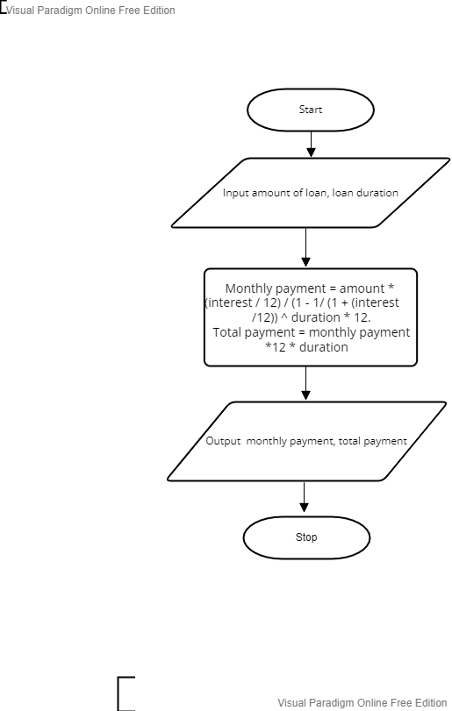

1. **Coding – Numerical Computation & Expression**
2. Coding

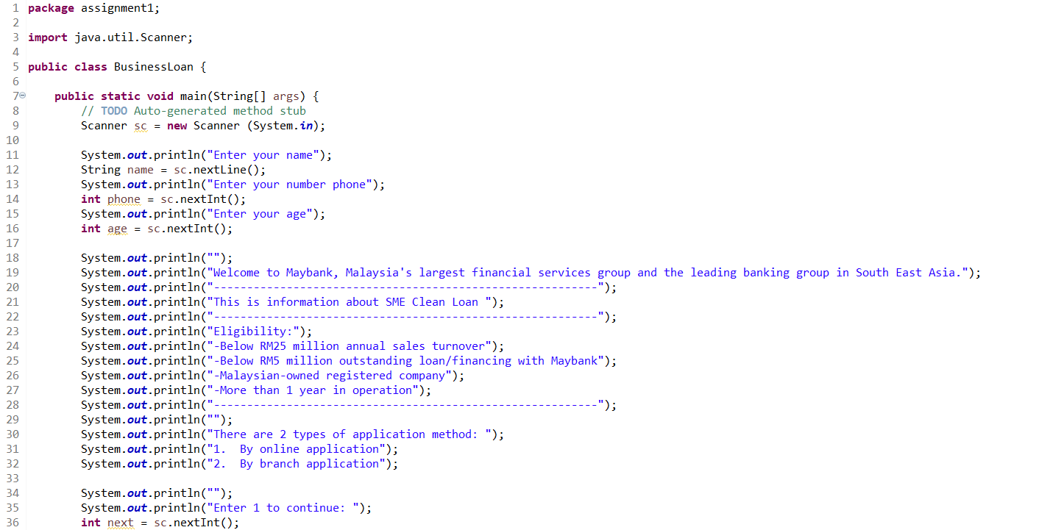

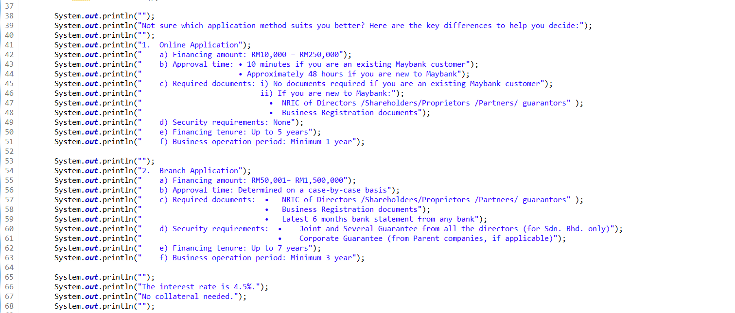

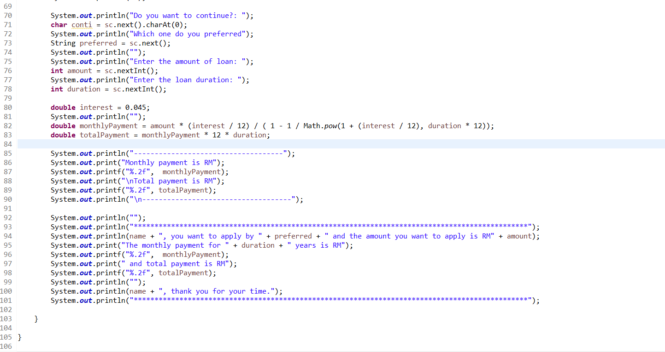

1. Output

